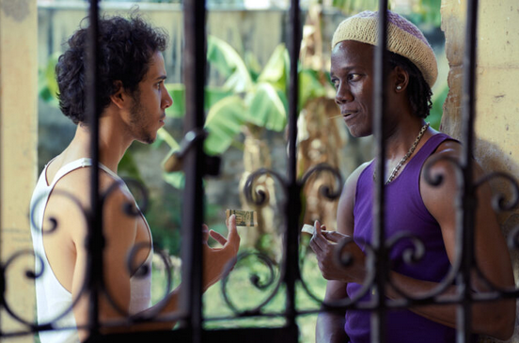


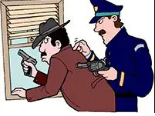
Colour Idioms

1. OMG! My bank account is in the red!
2. John was so green when he started at the company, that he thought that “know-how” was a North American indian greeting!
3. Peter’s friends call him yellow, because he always runs away from a fight.
4. A postcard from my aunt in Australia arrived yesterday out of the blue.
5. Things aren’t so black and white, you have to consider all the angles before you make a decision.
6. I go to the cinema once in a blue moon.
7. Jane is feeling blue today. She’s just lost her job.
8. My God, Lucy! You’re as white as a ghost – sit down and tell me what’s wrong.
9. It’s OK to tell a white lie once in a while.
10. Mary is the black sheep of the family, that’s why she was not invited.
11. The police caught Bob red-handed, so he’ll certainly go to jail.
12. The fact that she hasn’t answered any calls in 24 hours should raise a red flag.
13. I got a green light to go to the party on Saturday.
14. Guns are much cheaper on the black market, but I wouldn’t recommend them.
15. When you apply for citizenship, you face a lot of red tape.

Exercise. Which colour idioms are depicted in the images below?

a) ________________ b) __________________

c) ________________ d) __________________

